IET DEPARTMENT
BS CS Program



Data Structure and Algorithms
Lab Manual

Lab 1: Pointers
Objective
  - Memory addresses
  - Pointers
  - Types of pointers
  - Pointers Examples
  - Practice Task on pointers
Introduction
Computer Memory
Each variable is assigned a memory slot (the size depends on the data type) and the variable’s data is stored there
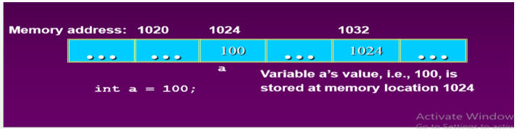
Pointers:
Pointers are a type of variable that allow you to specify the address of a variable. They provide a convenient means of passing arguments to functions and for referring to more complex data types such as structures. You need to declare and initialize pointers just as you would other variables, but there are special operators that you need to use.
Lab Manual Lecture [Expected time = 15 minutes]
Concept Map
Basic Pointer Revision
- Declaration of Pointer variables
type* pointer_name;
//or
type *pointer_name
Address Operator (&): The "address of " operator (&) gives the memory address of the variable.
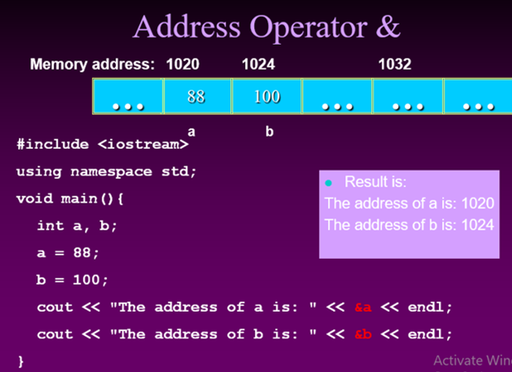
The * Operator Dereference: The star operator (*) dereferences a pointer. The * is a unary operator which goes to the left of the pointer it dereferences. The pointer must have a pointee, or it's a runtime error.
Test Program:
void PointerTest() {
// allocate three integers and two pointers
int a = 1; int b = 2; int c = 3; int* p; int* q;
// Here is the state of memory at this point.
// T1 -- Notice that the pointers start out bad...
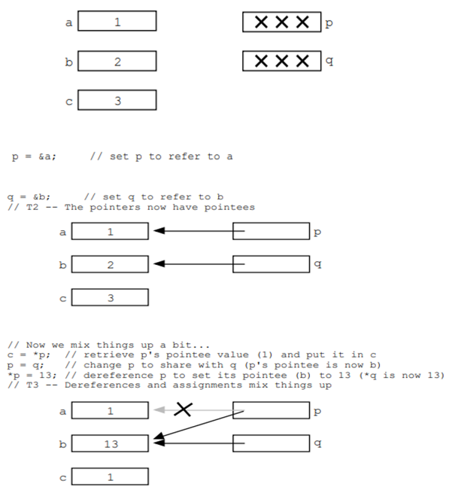
Pointer to Pointer
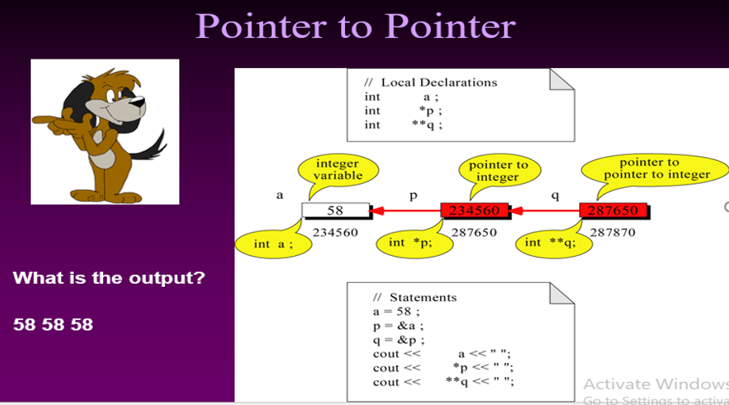
Types of Pointers
- Null Pointer
A pointer should be set to zero when it is not assigned to a valid address. Such a pointer is called a null pointer. Doing this will allow you to check whether the pointer can be safely dereferenced, because a valid pointer will never be zero.
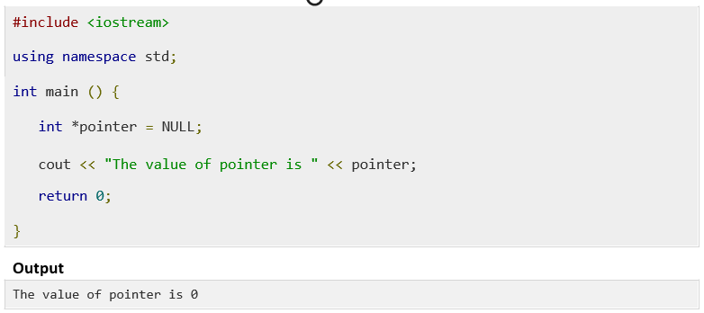
- Void Pointer
A void pointer is a pointer that has no associated data type with it. A void pointer can hold address of any type and can be type casted to any type.
int a = 10;
char b = 'x';
void *p = &a; // void pointer holds address of int 'a'
p = &b; // void pointer holds address of char 'b'.
How to increment pointer address and pointer’s value?
When we are accessing the value of a variable through pointer, sometimes we just need to increment or decrement the value of variable though it or we may need to move the pointer to next int position (just like we did above while working with arrays). The ++ operator is used for this purpose. One of the examples of ++ operator we have seen above where we traversed the array using pointer by incrementing the pointer value using ++ operator.
Pointer Arithmetic
pointer is an address which is a numeric value; therefore, you can perform arithmetic operations on a pointer just as you can a numeric value. There are four arithmetic operators that can be used on pointers: ++, --, +, and -
To understand pointer arithmetic, let us consider that ptr is an integer pointer which points to the address 1000. Assuming 32-bit integers, let us perform the following arithmetic operation on the pointer −
ptr++
the ptr will point to the location 1004 because each time ptr is incremented, it will point to the next integer. This operation will move the pointer to next memory location without impacting actual value at the memory location. If ptr points to a character whose address is 1000, then above operation will point to the location 1001 because next character will be available at 1001.
Sample Program
Incrementing Pointer
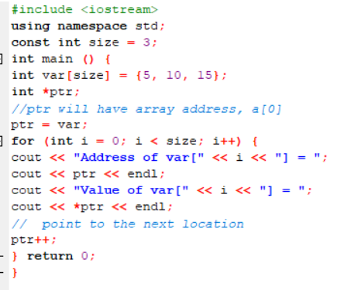
Decrementing Pointer
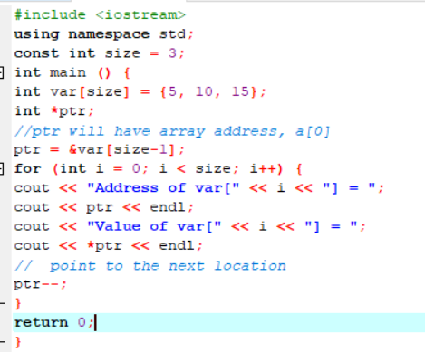
Pointers as Strings
A string is a sequence of characters. A string type variable is declared in the same manner as an array type variable is declared. This is because the string is an array of character type variables.
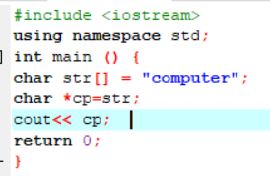
Passing Pointers as Arguments to Functions:
The pointer variables can also be passed to functions as arguments. When a pointer variable is passed to a function the address of the variable is passed to the function. Thus a variable is passed to a function not by its value but by its reference.
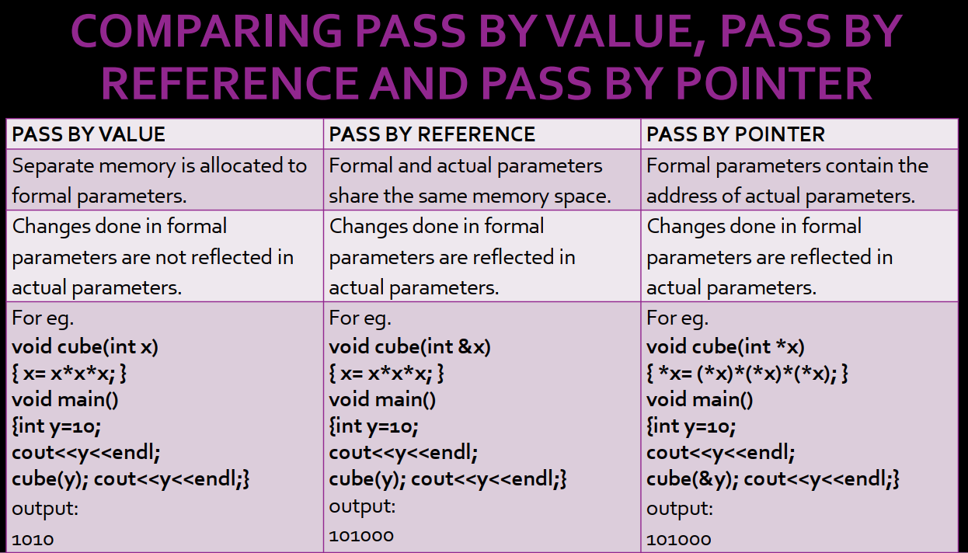
Sample Program
Write a program to pass two parameters to the function to add a constant value of 100 to the passed values using pointers.
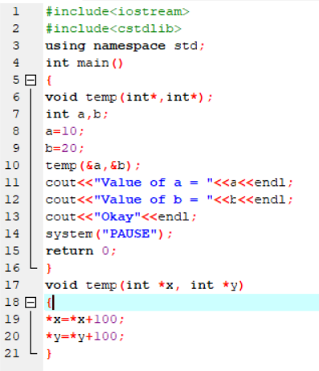
In the above program the function “temp” has two parameters which are pointers and are of int type. When the function “temp” is called the addresses of the variables “a” and “b” are passed to the function. In the function a value 100 is added to both variables “a” and “b” through their pointers. That is the previous values of variables “a” and “b” are increased by 100. When the control returns to the program the value of variable a is 110 and that of variable b is 120.
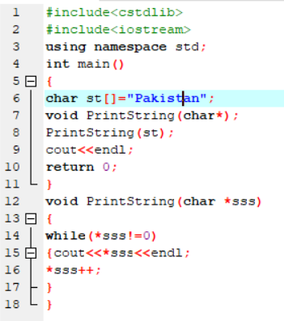
Practice Tasks
Time: 100 minutes
Task 1:
Write a program to convert Fahrenheit temperature to Celsius degree by passing pointers as arguments to the function.
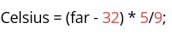
Task 2:
Write a program to find length of string by using pointers.
Task 3:
Write a program to input data into an array and find out the maximum value from array through pointers.

Evaluation Criteria
The evaluation criteria for this lab will be based on the completion of the following tasks. Each task is assigned the marks percentage which will be evaluated by the instructor in the lab whether the student has finished the complete/partial task(s).
Outcomes:
The outcomes of this lab were:
a) Students learn Pointers in C++
b) Learn and implement Pointers operations on array, strings etc.
c) Understand pointers types in C++

